**STARAGILE GIT AND GITHUB ASSIGNMENT -3**

1. **Create a file Demo.java which prints “Hello World”:**

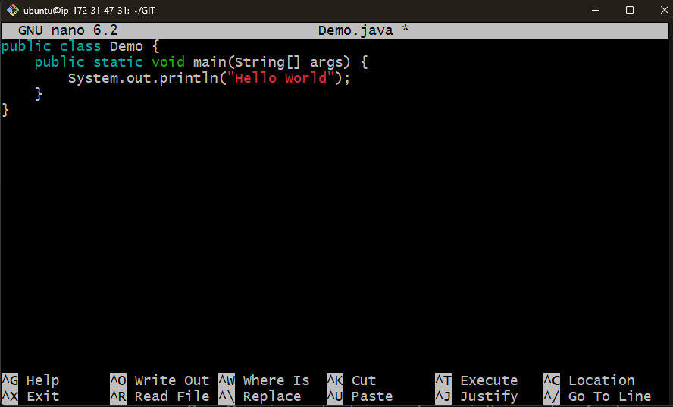

1. **Create 2 branches out of this master. Feature1 and Feature2:**

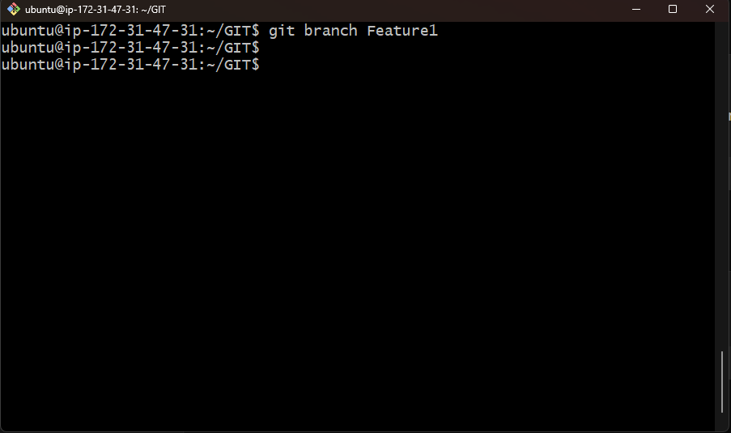

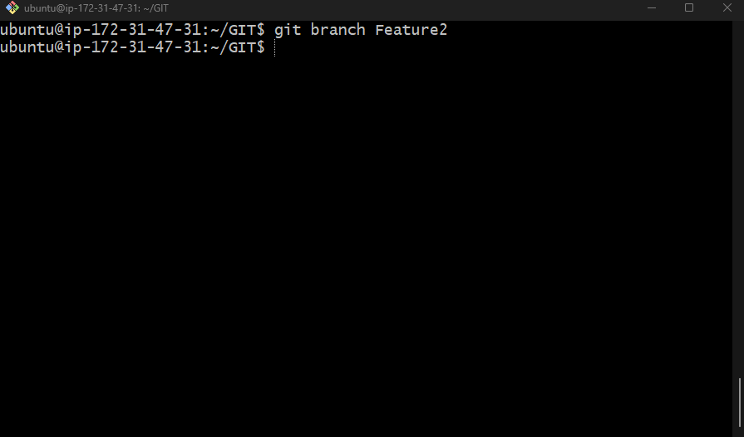

1. **Make changes in feature 1 branch code:**

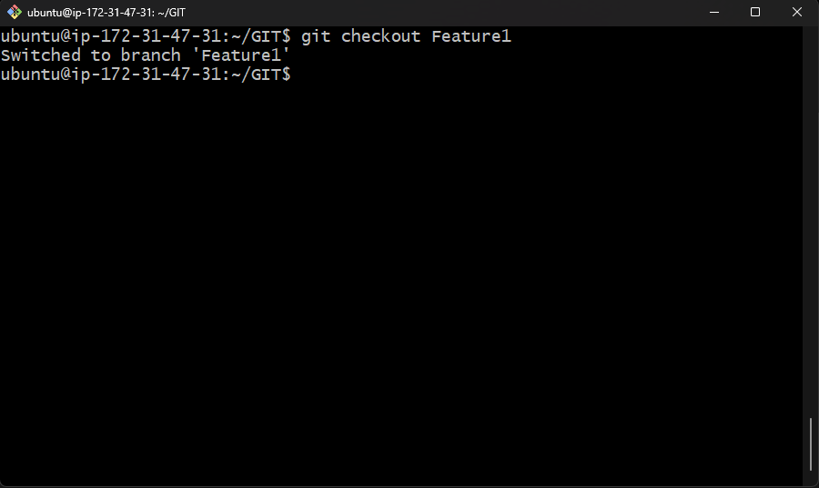

* + Open Demo.java and make some changes in the code.
  + Save the changes.

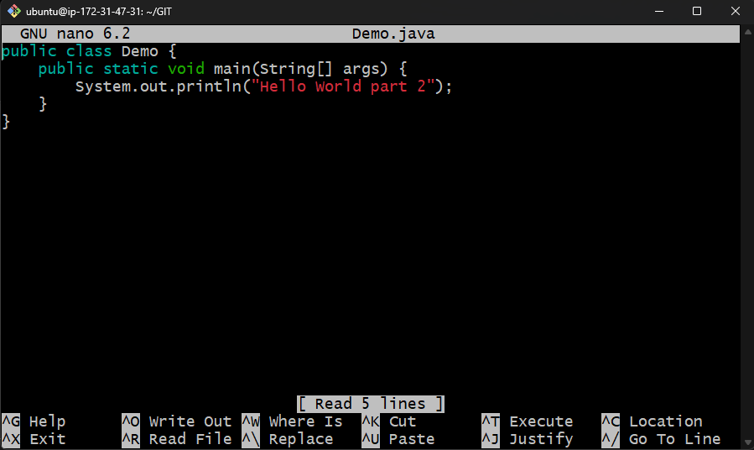

1. **Commit the code in feature1 branch:**

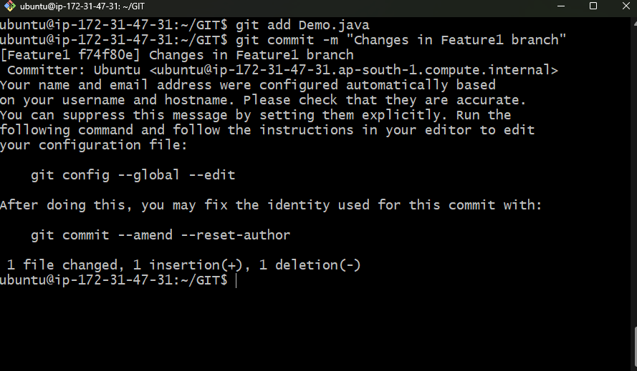

1. **Now checkout the feature2 branch and make a change in the same line as you did in feature1:**

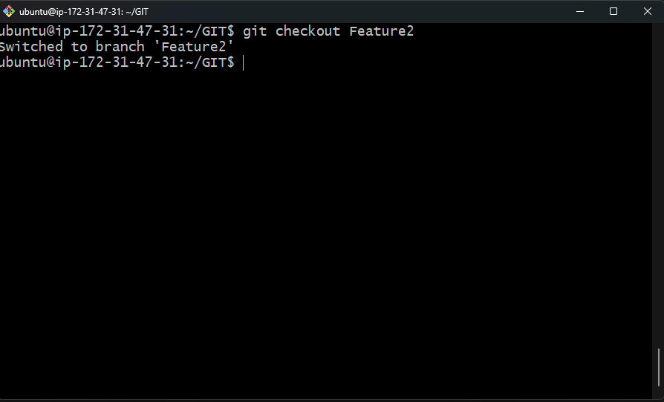

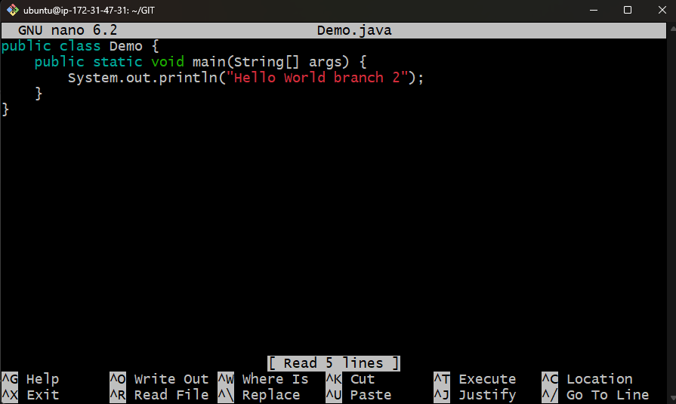

1. **Commit the code in feature 2 branch:**

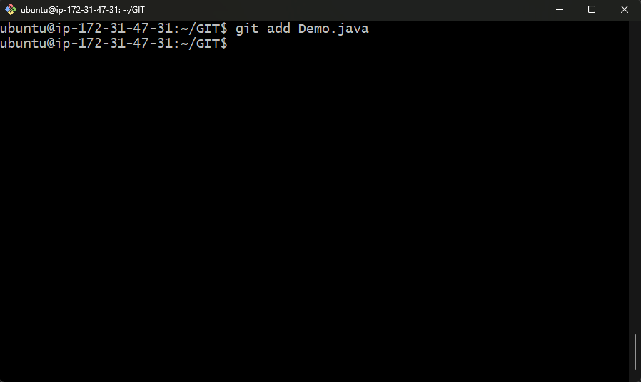

git commit -m "Changes in Feature2 branch"

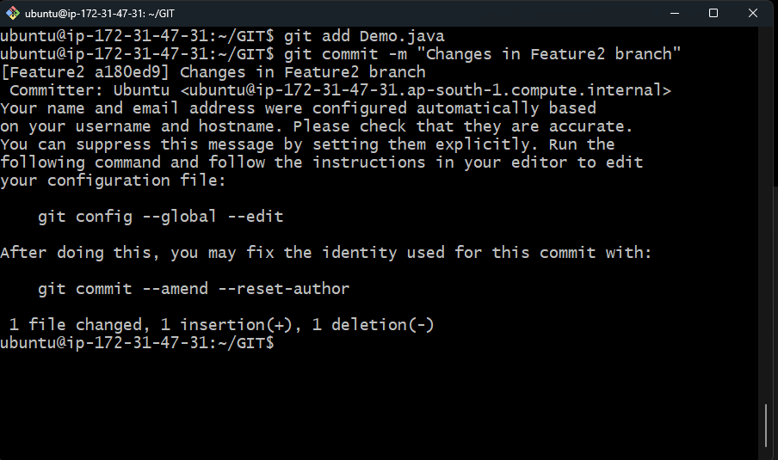

1. **Merge the Feature2 branch in Feature1 branch. It should give a merge conflict:**
   * Checkout the Feature1 branch

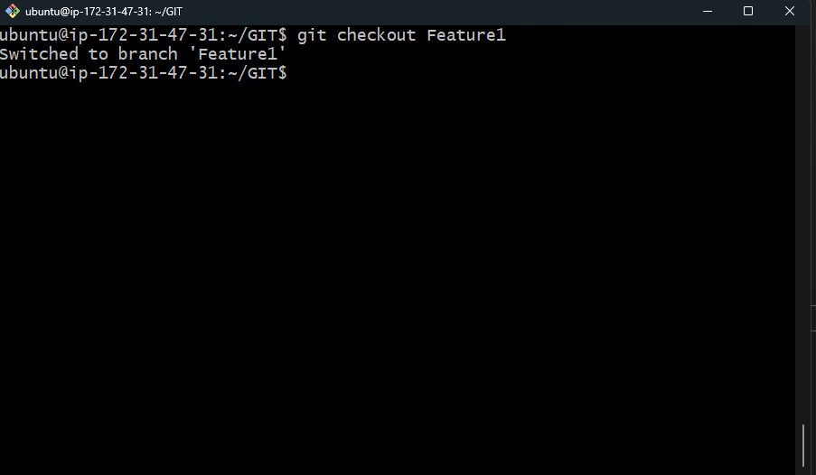

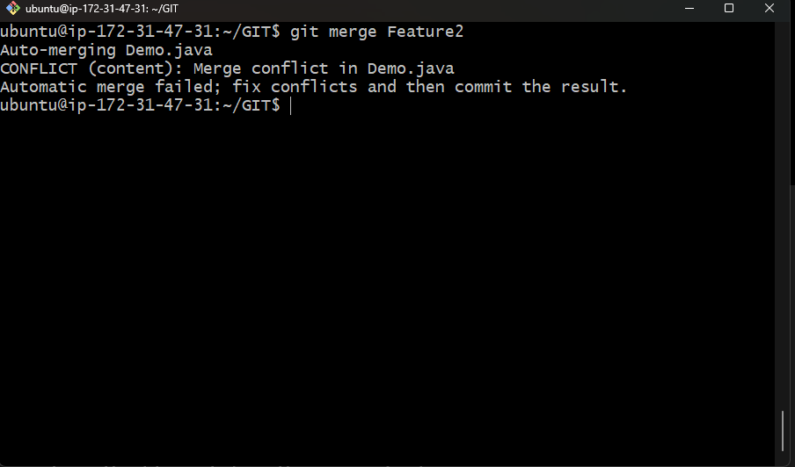

1. **Install Meld:**

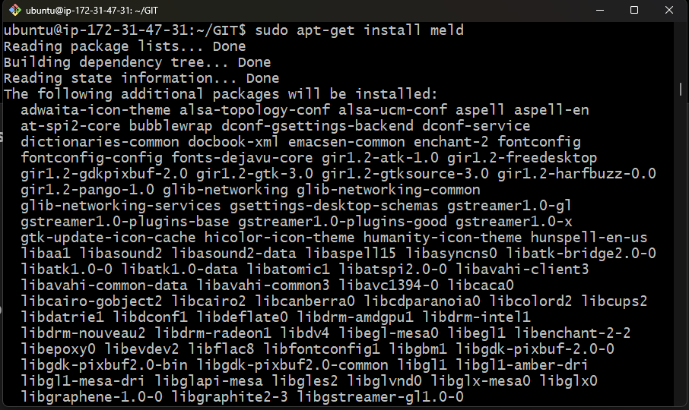

1. **Configure Git to use Meld as the merge tool:**

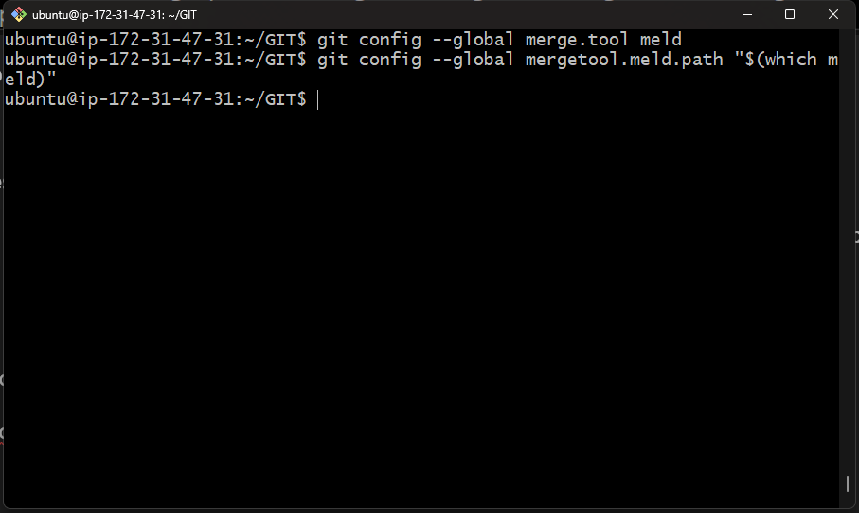

1. **Resolve the merge conflict with Meld:**

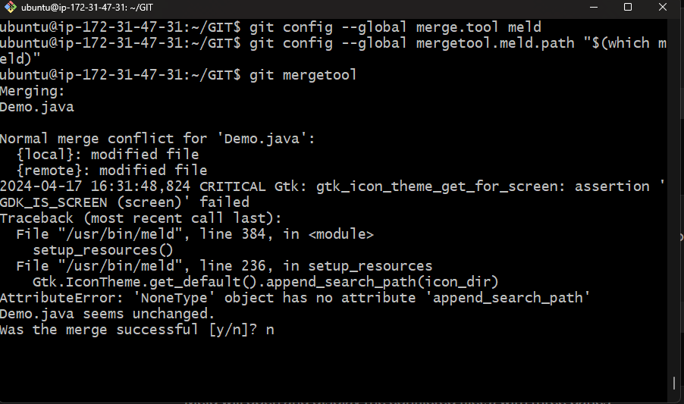

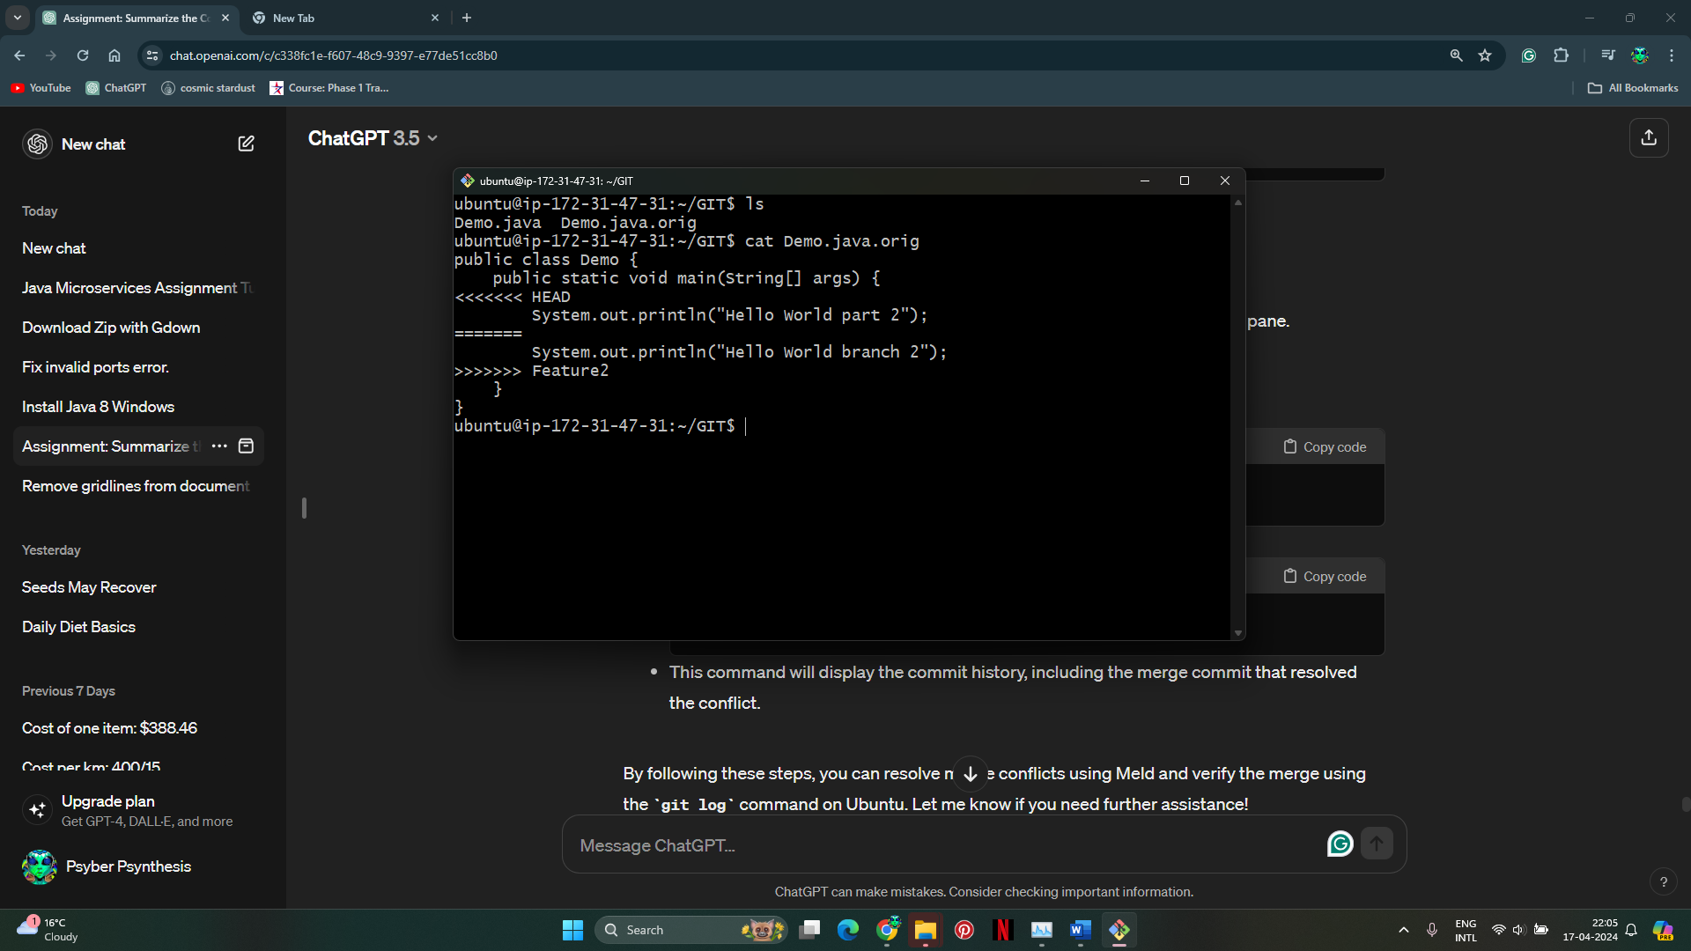

Manually resolve the conflicts

1. **Verify the merge using git log command:**

